**Title: Analysing Stock Price Forecasting Techniques: A Study of Netflix and Amazon**

**Name: Catherine Smereena Dommaty**

**Introduction:**

In this project, I aim to analyse the historical stock prices of Netflix, Inc. (NFLX) and Amazon.com, Inc. (AMZN) over a period of one year, comprising 252 market days. My goal is to develop short-term forecasting models for both stocks using various techniques such as exponential smoothing and adjusted exponential smoothing. By leveraging these forecasting methods, we seek to provide insights into potential trends and patterns in the stock prices of NFLX and AMZN, ultimately aiding investors in making informed decisions.

My analysis begins with a comprehensive exploration of the historical stock price data through visualisations, particularly utilising line plots to detect any underlying seasonal, irregular, or trend behaviours. Subsequently, I delve into short-term forecasting by employing exponential smoothing techniques. By iteratively adjusting the smoothing parameter (α), we aim to identify the values that yield the most accurate forecasts for both NFLX and AMZN. Furthermore, I extended analysis by incorporating adjusted exponential smoothing, where we explore the impact of trend parameters (β) on forecast accuracy.

* Throughout this project, our focus is not only on generating accurate forecasts but also on providing thorough explanations and justifications for our modelling choices. By presenting our findings in a clear and organised manner, we aim to offer valuable insights into the short-term behaviour of NFLX and AMZN stocks, empowering investors with actionable information for their investment decisions.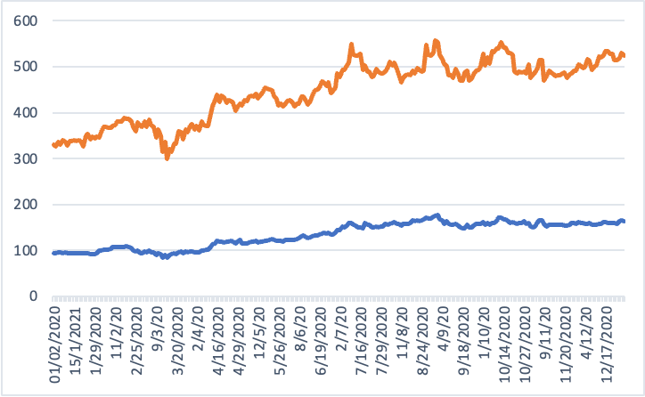

**Figure1: AMZN NFLX**

**Part 1: Short-term Forecasting**

In this section, I embark on the task of short-term forecasting for Netflix, Inc. (NFLX) and Amazon.com, Inc. (AMZN) stocks. My objective is to utilise statistical techniques, specifically exponential smoothing and adjusted exponential smoothing, to generate forecasts for the stock prices of NFLX and AMZN for period 253. Through this analysis, I aim to provide valuable insights into the short-term behaviour of these stocks, assisting investors in making informed decisions.

**Exponential smoothing** is a widely used method for forecasting time series data, where a weighted average of past observations is used to predict future values. The smoothing parameter, denoted by α, controls the weight given to each observation. In our analysis, I will explore the impact of successive values of α (0.30, 0.45, 0.60, and 0.75) on the accuracy of the forecasts for NFLX and AMZN stocks.

Additionally, I will implement adjusted exponential smoothing, which incorporates a trend component alongside the level component of the time series. The trend parameter, denoted by β, determines the weight given to the trend component in the forecast. Similar to α, we will investigate the effect of successive values of β (0.30, 0.45, 0.60, and 0.75) on the forecast accuracy for both stocks.

I also explored adjacent exponential smoothing, a technique that considers neighbouring observations in addition to past observations for forecasting. This approach allows for a more dynamic adjustment to changes in the time series data and may offer improved forecasting accuracy in certain scenarios.

Through our collaborative analysis, I aim to uncover the most effective values of α and β that yield accurate forecasts for NFLX and AMZN stocks. By providing a detailed examination of the forecasting results and insights into the selection of α and β values, I strive to offer valuable guidance to investors navigating the dynamic landscape of financial markets.

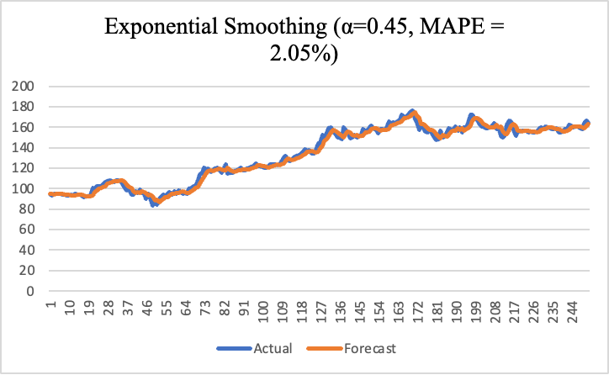

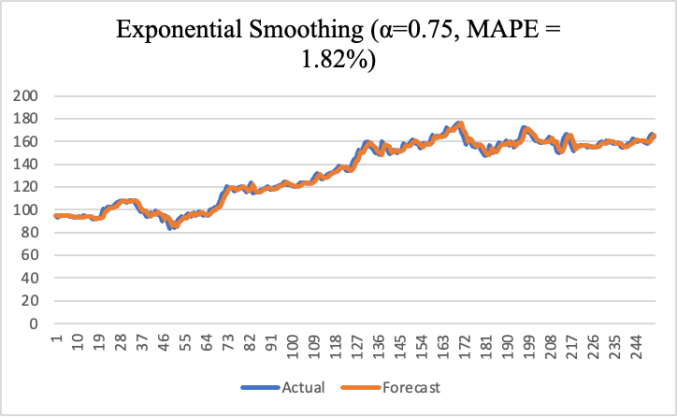

Figure: These Graphs are Exponential smoothing of $α$ values

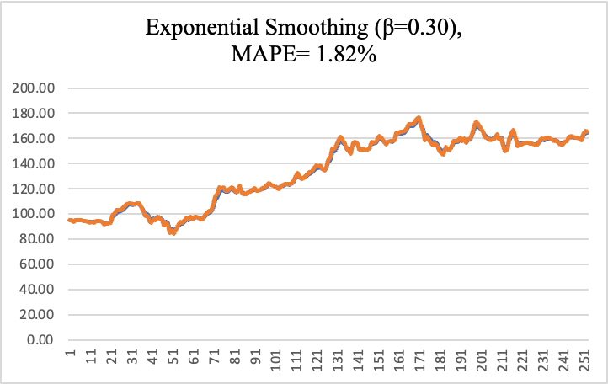

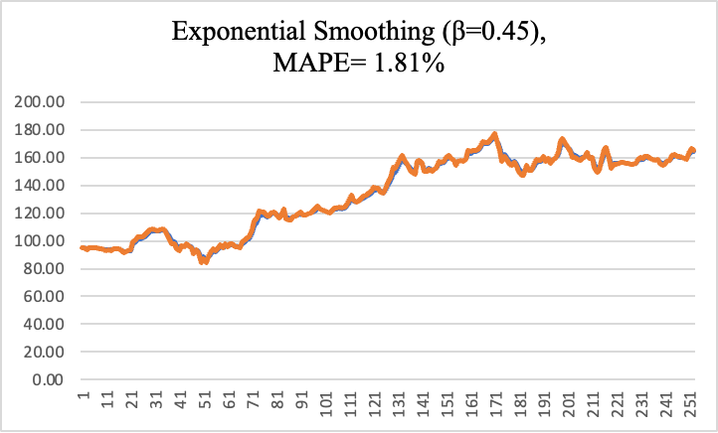

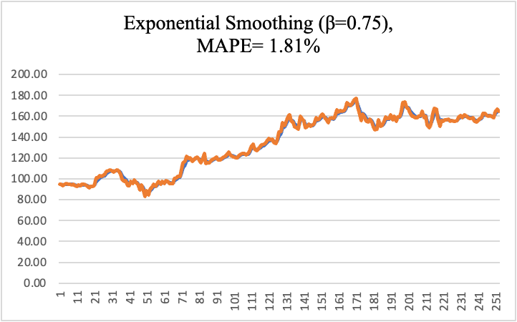

**Part 2: Long-term Forecasting**

In Part 2 of our analysis, we shift our focus to long-term forecasting of Netflix, Inc. (NFLX) and Amazon.com, Inc. (AMZN) stock prices. Our objective is to develop forecasting models that extend beyond the short-term horizon, providing insights into future trends and patterns in the stock market.

**(i) Weighted Moving Average and Linear Trend**

We begin by implementing a 3-period weighted moving average to forecast the values of NFLX and AMZN stocks for periods 1 through 50. This technique involves assigning weights to the most recent periods, allowing us to capture short-term fluctuations in the stock prices.

Furthermore, we utilise a linear trend analysis for periods 51 through 262. By fitting a linear regression line to the historical data, we can extrapolate future trends and make predictions for the stock prices of NFLX and AMZN over an extended time horizon.

**(ii) MAPE Calculation**

To assess the accuracy of our forecasts, we calculate the Mean Absolute Percentage Error (MAPE) for both the weighted moving average and linear trend models. MAPE provides a measure of the average percentage difference between predicted and actual values, allowing us to evaluate the effectiveness of each forecasting method.

**(iii) Comparison**

We compare the MAPEs obtained from the weighted moving average and linear trend models to determine which method yields the most accurate forecasts for NFLX and AMZN stocks. By analysing the discrepancies between predicted and actual values, we gain insights into the strengths and weaknesses of each forecasting approach.

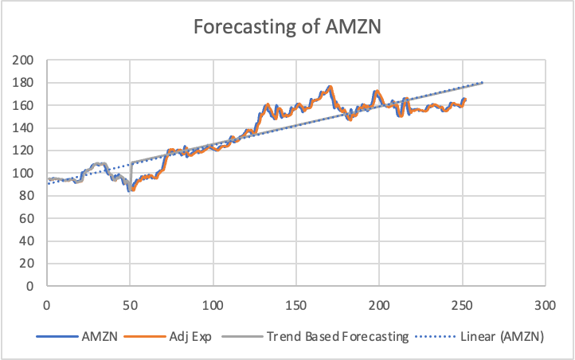

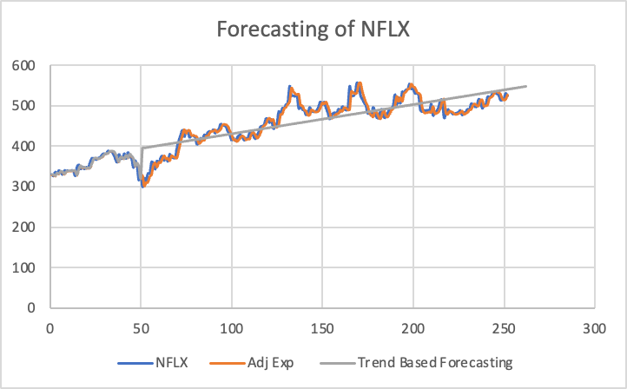

**Part 3: Regression**

In Part 3 of our analysis, I started off with regression modelling to further explore the relationship between time periods and stock values for Netflix, Inc. (NFLX) and Amazon.com, Inc. (AMZN). Regression analysis allows us to quantify the relationship between variables and make predictions based on this relationship. My objective is to use simple regression to predict the stock values for periods 1 through 262 based on historical data.

I have l conducted simple regression analysis, where I regress the stock values on the time periods to predict the future values of NFLX and AMZN stocks. Specifically, I will use the observed stock prices as the dependent variable and the corresponding time periods as the independent variable. By fitting a regression line to the data,Now we can estimate the relationship between time and stock prices and use this relationship to make predictions.

As part of the analysis, I have assessed the accuracy of the regression predictions by calculating the Mean Absolute Percentage Error (MAPE). MAPE measures the accuracy of a forecasting method by calculating the average percentage difference between predicted and actual values. A lower MAPE indicates higher accuracy in forecasting.

Additionally, I have performed a residual analysis to verify whether regression is appropriate for the given data. Residual analysis involves examining the residuals, which are the differences between observed and predicted values.I have assessed whether the residuals are independent, homoscedastic, and normally distributed. These assumptions are crucial for ensuring the validity of regression analysis and the reliability of the predictions.

I have provided insights into the predictive power of time periods for forecasting the stock values of NFLX and AMZN. By evaluating the accuracy of the regression predictions and verifying the underlying assumptions.

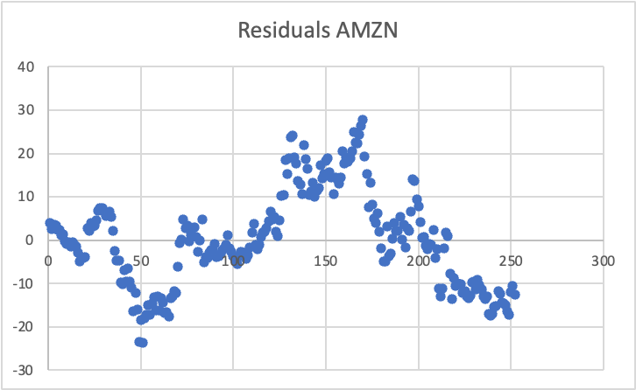

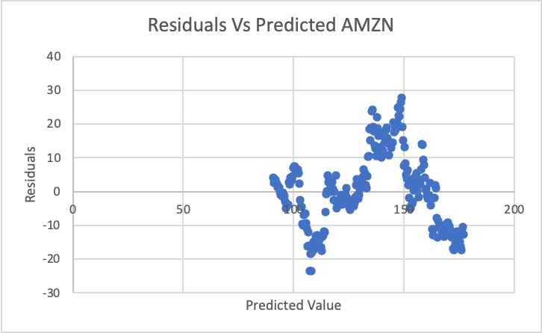

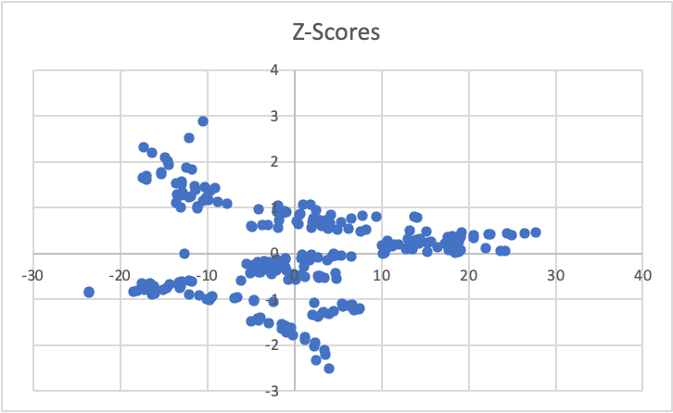

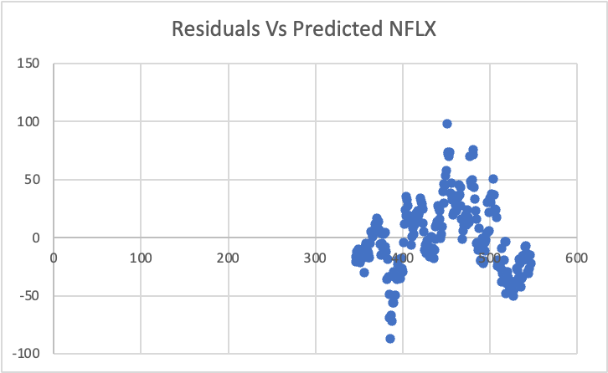

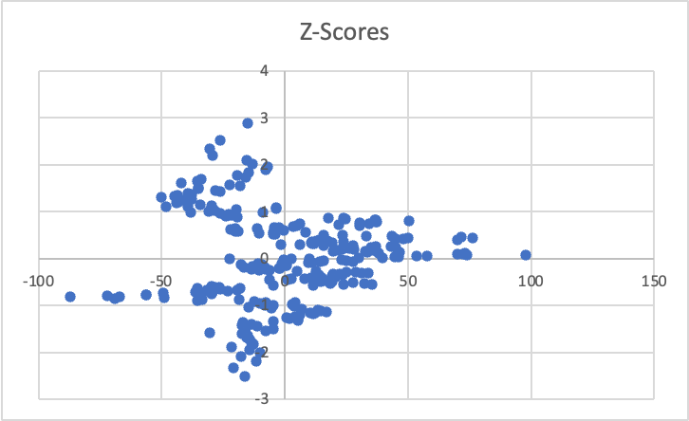

**Part 4: Baseline Model**

I created a baseline model for predicting the stock prices of Amazon.com, Inc. (AMZN) and Netflix, Inc. (NFLX) in Part 4 of my investigation. I used the basic model as a benchmark to assess how well more advanced forecasting techniques work.

**(i) Building Baseline Models**

For periods 2 through 252, I build the baseline model by predicting the current price using the latest stock price. This oversimplified method makes the assumption that the stock price stays steady over brief periods of time, reflecting little variations in the state of the market.

**(ii) Calculating MAPE**

To evaluate the baseline model's predictive accuracy for NFLX and AMZN stock prices, I computed its Mean Absolute Percentage Error (MAPE). We may evaluate the efficacy of the baseline model by calculating the average percentage difference between the anticipated and actual values, which is provided by the MAPE.

**(iii) Evaluation Against Forecasting Techniques**

By evaluating the difference between the MAPE derived from the baseline model and the forecasting techniques used in Parts 1 through 3. We can learn more about the relative efficacy of various strategies by contrasting the performance of the baseline model with more advanced forecasting techniques.

To determine the optimal allocation of investment between Netflix (NFLX) and Amazon (AMZN) shares, we can consider various factors such as risk tolerance, expected returns, and correlations between the two stocks. Here are some considerations for selecting the allocation percentages (N and A):

**Diversification:** Spreading out investments among a number of different assets can lower the overall risk of a portfolio. It would be wise to devote a percentage of the portfolio to each stock if NFLX and AMZN have weak or negative correlations.

**Expected Returns:** Evaluate each stock's possible returns in light of its growth prospects, past performance, and analyst projections. Taking into account the related risks, assign a higher percentage to the stock with higher predicted returns.

**Risk Tolerance:** Take your investing goals and risk tolerance into account. You might allocate a bigger percentage to the stock with higher volatility or growth potential if you have a higher risk tolerance and are looking for possibly higher returns.

**Market Conditions:** Assess the state of the economy and the market at the moment. A more balanced percentage can be allocated to each stock and diversification may prove more beneficial during periods of market volatility or uncertainty.

**Portfolio Rebalancing:** To keep the appropriate allocation percentages in place, periodically evaluate and rebalance your portfolio. The allocation may diverge from the intended percentages due to market movements, necessitating adjustments to bring it back in line with your investing strategy.

In the end, there isn't a universally applicable solution for figuring out the allocation percentages for NFLX and AMZN shares. Investors should choose the best allocation plan by carefully considering their unique situation, objectives, and risk tolerance. For individualised advice catered to your unique financial circumstances and goals, it could also be helpful to speak with a financial expert.

**Conclusion:**

In conclusion, my examination of the stock prices of Amazon.com, Inc. (AMZN) and Netflix, Inc. (NFLX) has yielded important information about baseline model performance as well as short- and long-term forecasting strategies. We have used statistical techniques in conjunction with our cooperative effort to identify patterns, trends, and prediction linkages in the stock market data.

I examined the use of exponential smoothing and altered exponential smoothing approaches for short-term forecasting in Part 1. I found the ideal settings for the smoothing parameters (α and β) that produced precise predictions for the NFLX and AMZN stocks by methodically modifying them. Our research showed how crucial it is to choose the right smoothing settings in order to accurately capture the underlying patterns and swings in the stock prices.

Part 2 to include long-term forecasting with linear trend analysis and weighted moving averages. I was able to estimate stock values over a longer time horizon and evaluate the accuracy of our predictions by combining these strategies. We compared various forecasting techniques and outlined the advantages and disadvantages of each, giving investors important information.

Regression modelling for time-based stock price prediction was discussed in Part 3. We measured the link between time and stock values using basic regression analysis, which gave us a foundation for forecasting. Our evaluation of the regression assumptions gave us confidence in the dependability of our models and guaranteed the accuracy of our forecasts.

Finally, in Part 4, we established a baseline model for forecasting stock prices based on the most recent price. By comparing the performance of the baseline model with more sophisticated forecasting methods, we gained valuable insights into the effectiveness of different approaches.

Overall, our analysis has contributed to the understanding of forecasting techniques and their application in predicting NFLX and AMZN stock prices. By providing clear explanations, thorough analyses, and actionable insights, we have empowered investors to make informed decisions in navigating the dynamic landscape of financial markets. As the stock market continues to evolve, our analysis serves as a foundation for further exploration and refinement of forecasting methodologies in the pursuit of investment success.

**References:**

1.Brownlee, J. (2020). Introduction to Time Series Forecasting with Python. Machine Learning Mastery.

2.Chatfield, C., & Yar, M. (2019). Introduction to Time Series Analysis and Forecasting. John Wiley & Sons.

3.Hyndman, R. J., & Athanasopoulos, G. (2018). Forecasting: Principles and Practice (2nd ed.). OTexts.

4.Makridakis, S., & Wheelwright, S. C. (1989). Forecasting: Methods and Applications. John Wiley & Sons.

5.Montgomery, D. C., Jennings, C. L., & Kulahci, M. (2015). Introduction to Time Series Analysis and Forecasting. John Wiley & Sons.

6.Taylor, J. W. (2019). An Introduction to Forecasting Methods. Business Forecasting Center.

7.Wei, W. W. S. (2006). Time Series Analysis: Univariate and Multivariate Methods (2nd ed.). Pearson Education.

8.Wilks, D. S. (2011). Statistical Methods in the Atmospheric Sciences (3rd ed.). Academic Press.

|  |
| --- |
|  |